Subject Name: **Source Code Management**

Subject Code: **CS181**

Cluster: **Beta**

Department: **CSE**



Submitted By: Submitted To:

Anmol Sharma Dr. Deepak Thakur

2110990212

G03



**Experiment No. 01**

**Aim:** setting up Git Client

Steps to Install Git on Windows

1. Download the latest git for windows

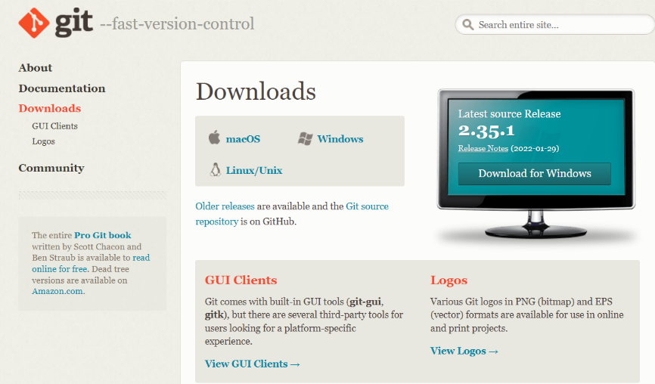

2. Install git 64-bit Setup for windows

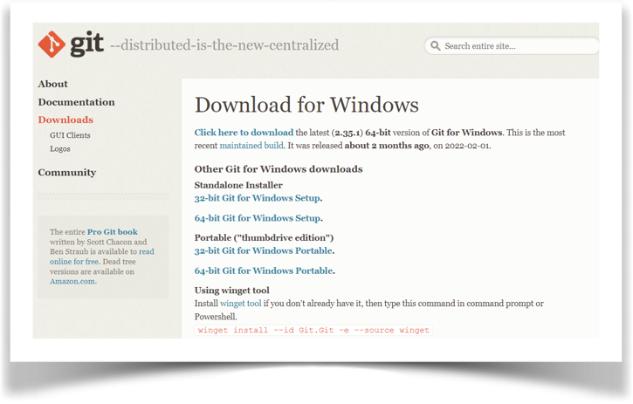

3. You may like to keep the installation to another folder, so here is the chance to do so. I just want to keep it in the suggested default folder in my Program Files\Git.

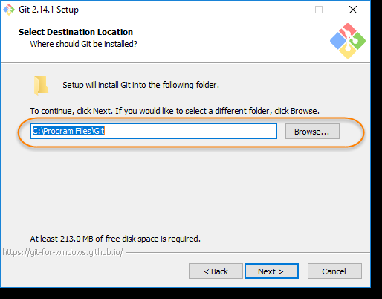

4. This is the option to store the shortcut of the Git under the ProgramMenu.

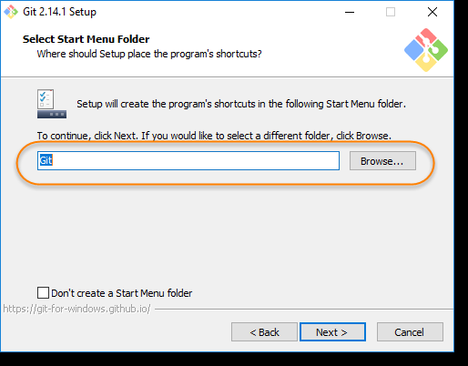

5. This is asking your choice that whether you like to Git from the Windows Command Prompt or you like to use some other program like Git Bash. As of now just select the Windows Cmd for simplicity of the tutorial, later we will cover Git Bash and other as well.

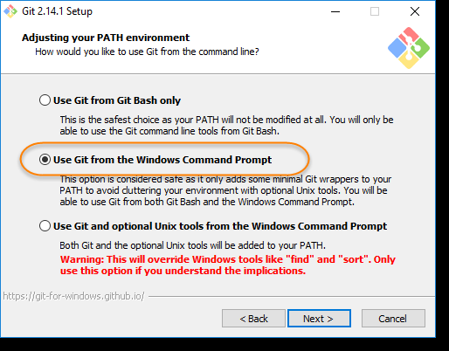

6. If you have PuTTY/TortoiseSVN installed, you may see this screen, otherwise just ignore this. Regardless, use OpenSSL to make things easy

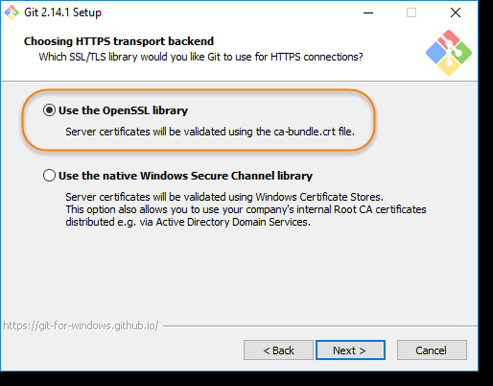

7. Here, we recommend to choose the option of Checkout Windows-style, commit Unix-style line endings. Select next once you have done this.

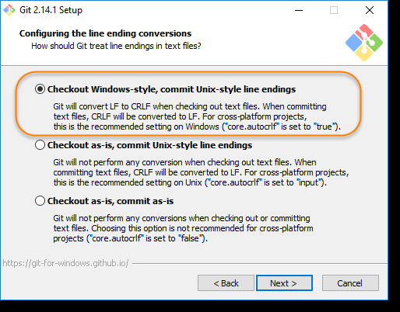

8. Again, just go with default selection and move forward.

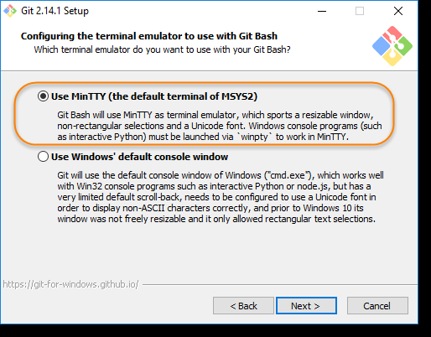

9. Just go with default selections, as we will cover the details in later advance chapter.

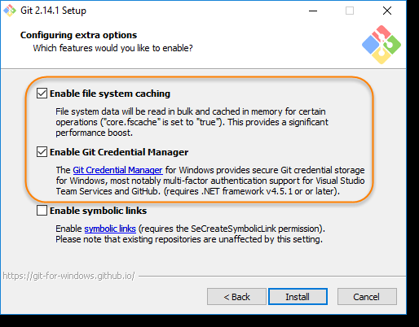

10. Now, its all done. This will just take few minutes to complete the installation as per your machine speed.

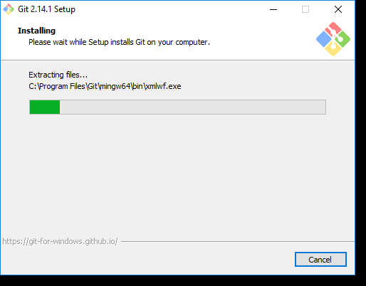

11. Once done, just click on Finish button.

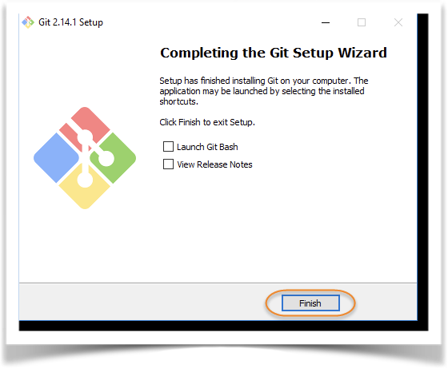



**Experiment No. 02**

**Aim:** Setting up Git account

1. Go to github.com and click on signup option at the top right corner of the screen

2. Follow up the instructions popping up on screen to create your GitHub Account

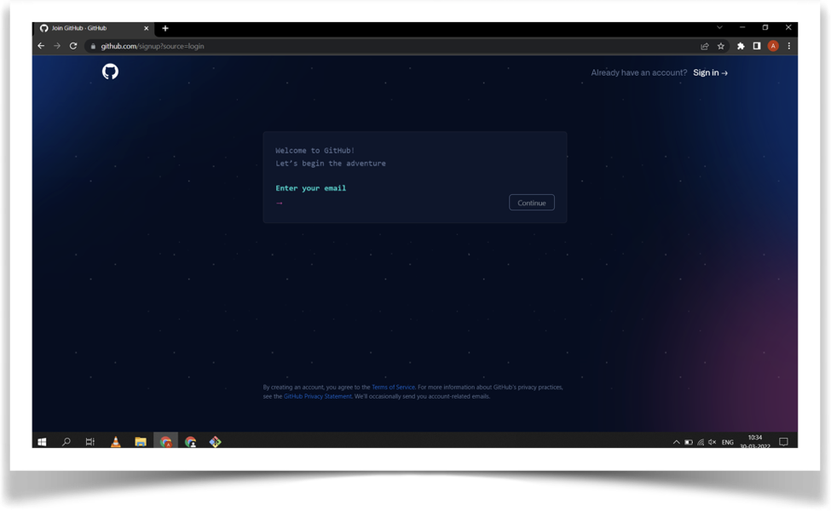

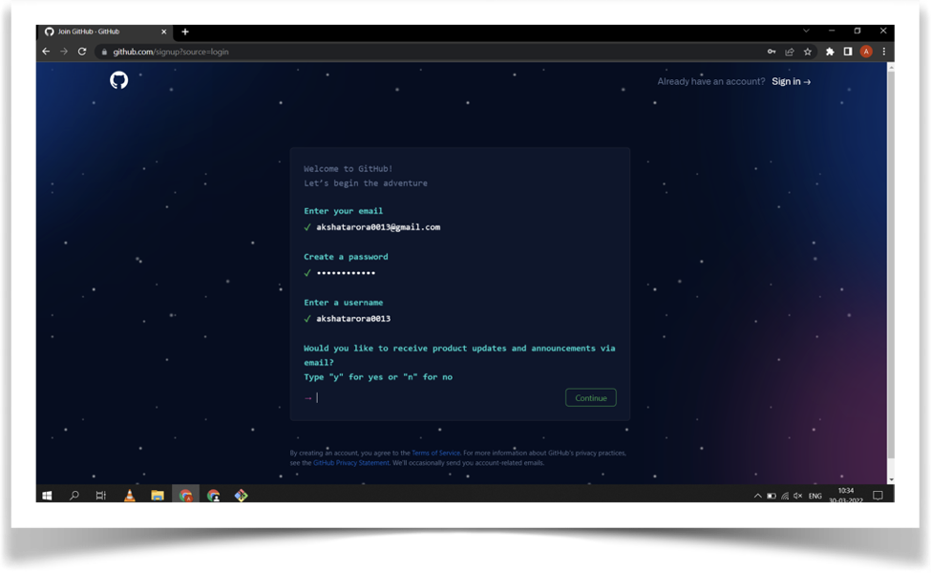

**How to Set Up Default Credentials for Git Config?**

Set user's UserName in Git Config

The first change that we will be making inside our config file will be changing our username in Git. To change our username, follow these steps.

Open Git Bash in your system. Type the following command with your username: git config --global user.name "Your User Name"

**Set user's Email in Git Config**

After executing the above command successful, now we will change our email. By Type the following command.

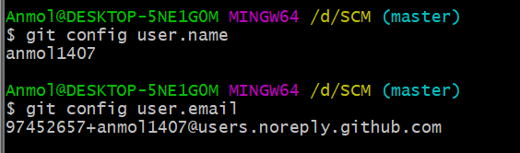

git config --global user.email "Your EmailID”

git config --global user.name “Your Name ”



**Experiment No. 03**

**Aim** : Program to generate logs

git log command is used to generate logs

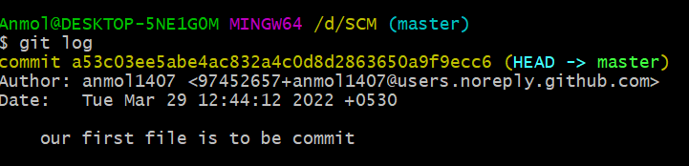



**Experiment No. 04**

**Aim** : Create and visualize branches

**HOW TO CHANGE BRANCH IN GIT**

The git branch command lets you create, list, rename, and delete branches. It  
doesn’t let you switch between branches or put a forked history back together

again. For this reason, git branch is tightly integrated with the git checkout and git merge commands.

**Why do we need a Branch in Git and Why Branches Are Important?**

Git branches come to the rescue at many different places during the development of a project. As mentioned above, branches create another line of development that is entirely different or isolated from the main stable master branch. There are many advantages to doing so.

Consider that you are developing a project with your team, and you finish a feature. You contact the client to request them to see the feature, but they are too busy, so you send them the link to have a look at the project. Okay, it's lengthy to explain in words. Let's see the same project development in different phases through images.

**How to view a Local Branch in Git?**

Open Git Bash and navigate to the local working repository. Type the following command to view all of your branches.

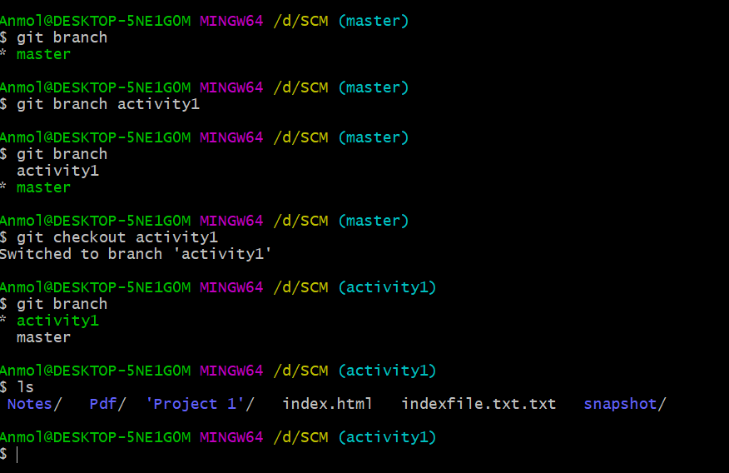

**How to Create a Local Branch in Git?**

Let's create a new branch now in our local working repository. Type the following command to create a new branch named "branch1"

git branch <branch_name>

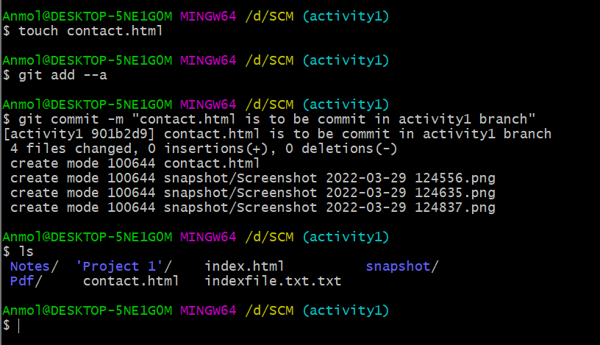

**How to Switch Branch in Git?**

Check the branch you are currently on, which is visible alongside the directory name.  
Switch to the "branch1" by executing the command:

git checkout branch1

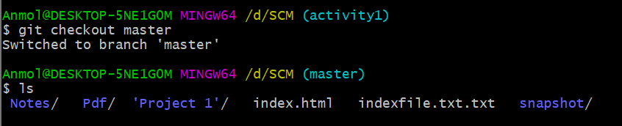

**How to merge branch in Git to another branch?**

1 -First switch to new branch, and make a new file by using following command.

2 - Now after making changes in branch1 use the following command to merge the two branches.  
git merge <branch name>



**Experiment No. 05**

**Aim** : Git life cycle description

General workflow is as follows −  
• You clone the Git repository as a working copy.  
• You modify the working copy by adding/editing files.  
• If necessary, you also update the working copy by taking

other developer's changes.  
• You review the changes before commit.  
• You commit changes. If everything is fine, then you push

the changes to the repository.  
• After committing, if you realize something is wrong,

then you correct the last commit and push the changes to the repository.

